​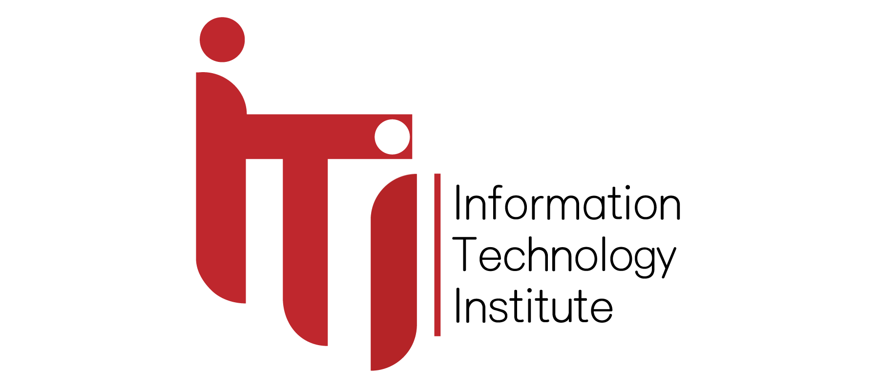

**Examination System**

Supervisor:

Eng. **Sara Saleh**

**Presented by:**

Abdulrahman Mokhles

Marina Ayman

Steven Kromer

## ABSTRACT

For assessing and improving qualifications proficiency we need an essential tool to tell us whether these qualifications are put in their right places or not, to this reason, we introduce an examination system used to evaluate a student’s knowledge and understanding of a particular subject or course.

The exam results can be used to identify areas that require improvement and to guide training and development efforts, and even these we are conversant with online courses as exceeded besides freelancing jobs to trace what students learned.

Moreover, the examination system is an essential component of the assessment process, which helps ensure quality education. As such, educational institutions need to design examination systems that are fair, reliable, and valid, to ensure that students receive accurate and meaningful feedback on their learning progress.

## INTRODUCTION

The pace of technological advancement is accelerating at an unprecedented rate, and it is evident that technology is expanding and improving day by day, it has become more important for us to adapt and understand our needs in this ever-evolving landscape; hence, the examination system serves as a crucial tool in accurately assessing our current knowledge, it enables them to identify strengths and weaknesses, track progress, and make data-driven decisions about training and development needs, and identifying areas for growth to keep pace with the advancements of technical skills in the data science and other courses.

It will consist of departments divided into instructors that will facilitate studying to students and take their hands towards their careers, courses cope with the technology evolution with the increasing importance of data-driven decision-making towards the ability to work with Python, OOP, SQL, Data warehouse, data mining, and other tracks including C++, C#, Java, HTML, and JavaScript as it is becoming essential for students who develop himself by studying more and more with professional instructors, and companies who develop the country by those students. It can incorporate different types of exams, such as multiple choice, true or false. these types will be faster and more useful for mental health struggles.

Because of guarantee a healthy study, we suggest getting the student’s health status and their emergency contact to guarantee the students’ health and assure that they can meet deadlines, and achieve good grades without stress and anxiety for students’ effect on any disease he has, particularly if they are struggling with technical subjects or feel overwhelmed by the workload.

By taking exams and receiving feedback on their performance, individuals can identify areas where they need to improve and focus their learning efforts accordingly. This can help them stay up-to-date with the latest technologies and best practices in the field, after the student gives his feedback, he can get his grades to decide if he should repeat the course content or if he already reached the stars from it, and now he has finished all courses so, it is his time to be certified an individual's proficiency from the intake, as certifications can serve as valuable credentials for job seekers and employers seeking to hire skilled professionals.

To demonstrate proficiency to potential employers and increase job prospects after getting their grades from the examination system can be used to certify individuals' proficiency as certifications in each online course or once completing the intake, which can serve as valuable credential certification for job seekers and employers seeking to hire skilled professionals’ system also enables individuals to benchmark their skills and knowledge against industry standards and best practices. This can be useful for identifying improvement areas and setting personal and professional development goals.

In the intake, online courses and freelancing jobs can be used in conjunction with the examination courses system to create a comprehensive learning experience. For example, individuals can take exams to evaluate their proficiency before and after completing online programs to assess their learning progress.

Dashboards can be created to visualize the exam results, allowing instructors and individuals to track their progress toward mastery of the subject matter. The dashboards can provide detailed information about the student’s enrolment process till taking the courses to finish them with the final intake certificate qualify them to work in a fitting company, also presented the data from stored procedures to SQL Server Report Server that shows exams by each exam number.

## IMPLEMENTATION LIFE CYCLE

The implementation life cycle is an iterative process needed to ensure the system meets the requirements that outline the phases a system goes through, from entity relationship diagrams to reports and interactive dashboards.

**ERD:** In this phase, we created detailed design specifications for the entity relationship diagram, and database schema, and developed dashboard perspectives.

**Database creation:** Here, we coded the database schema, integrated the components into a working system, and tested the system to ensure it can manage exams and answers.

**SSRS:** SQL Serverreport server to present the data from stored procedures to SQL Server Report Server to show the targeted report like different courses, topics, and exams.

DATABASE DESIGN (ERD)

Examination system ERD includes entities such as Intake, department, students, questions, feedback, exams, courses, grades, health status, and their relationships to each other.

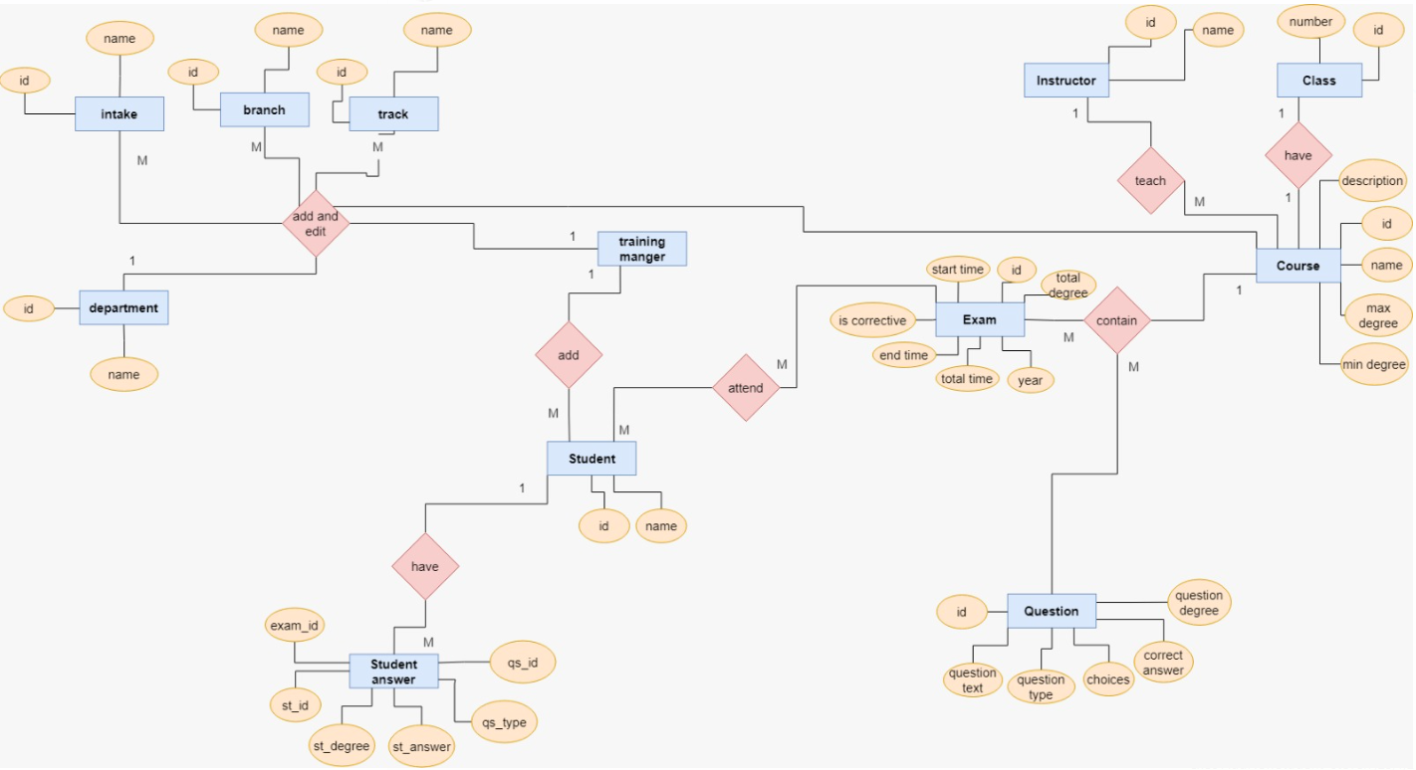

IMPLEMENTATION

Creating a database for an examination system typically involves defining tables to store information about the Topic, Course, Instructor, Student, Department, Exam, Graduate, and Feedback. Once we defined the table schema, we populated the tables with data. We used the Bulk Insert command. This command allows for the efficient insertion of large amounts of data into tables from a data file. The data file can be CSV in our system.

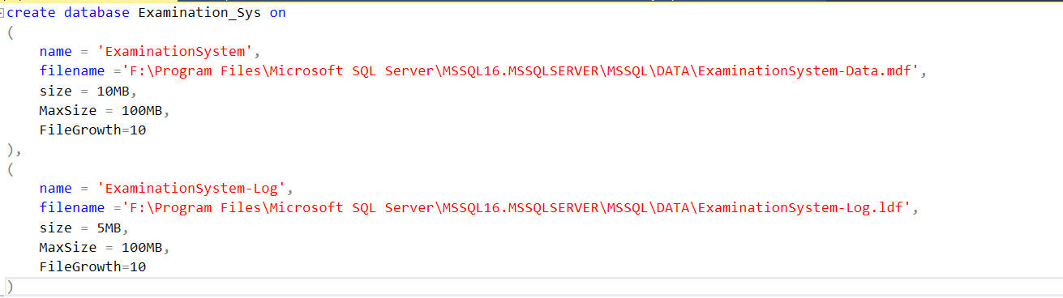

**Student Table**

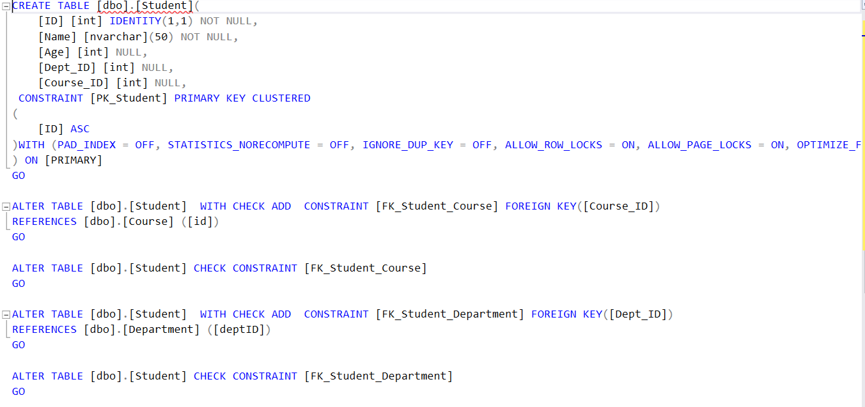

Add Student Stored Procedure

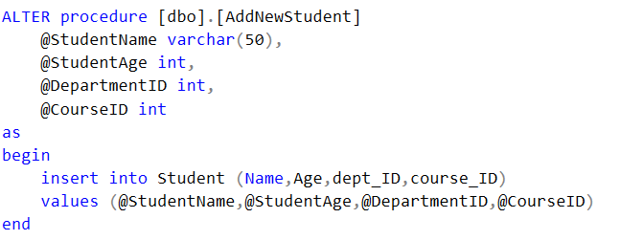

**Update instructor Stored Procedure:**

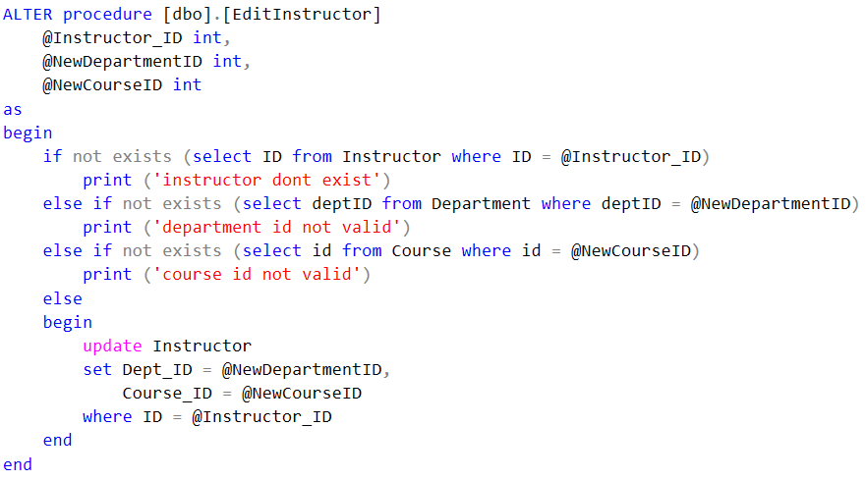

**Delete Question Stored Procedure:**

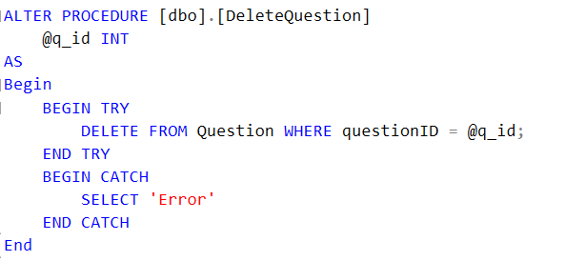

**Exam generation stored procedure**

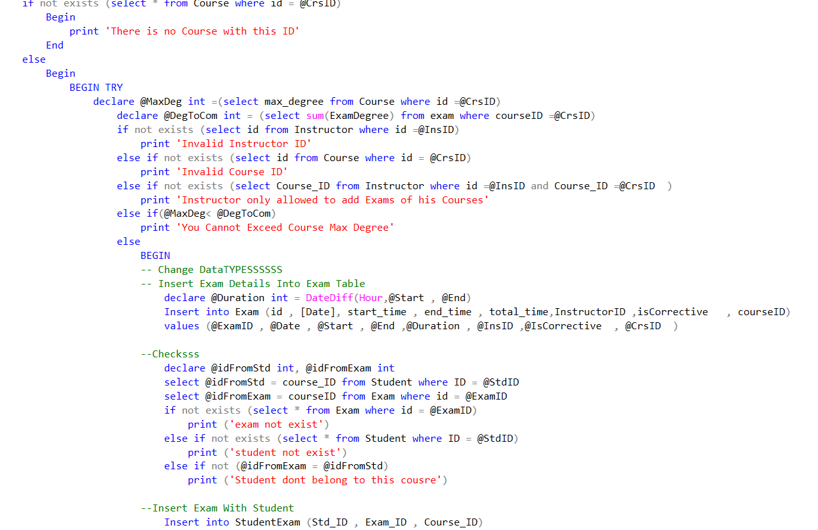

**StoreAnswers stored procedure**

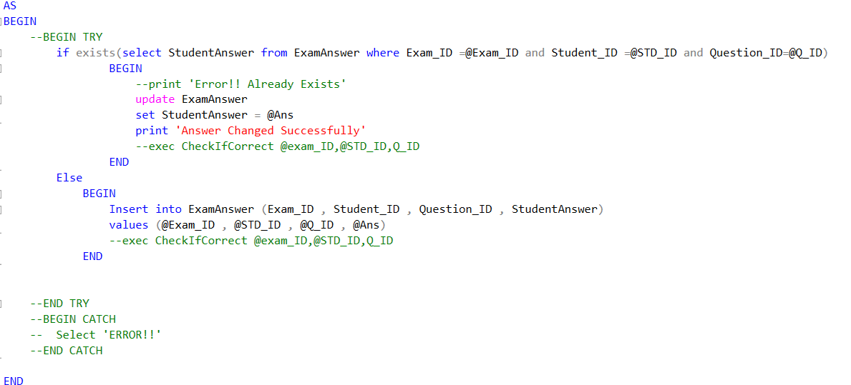

**CheckIfCorrect stored procedure**

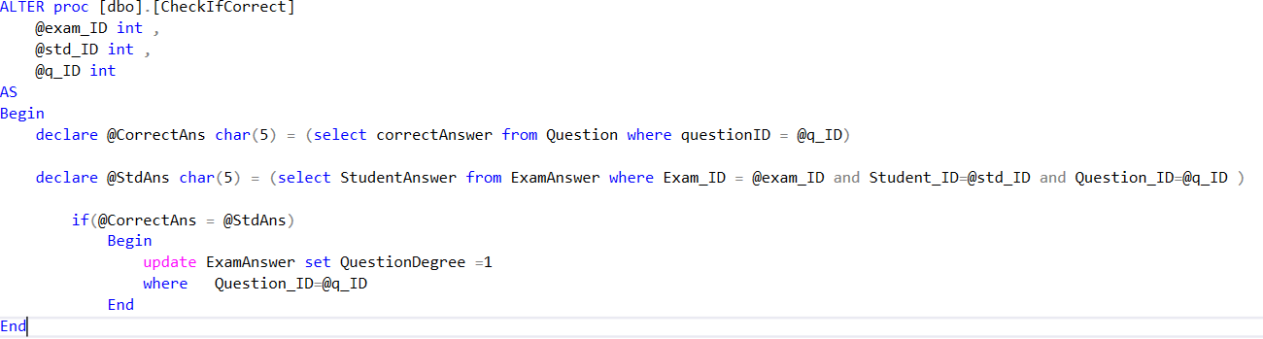

**Total Answer Procedure**

